How To Write Formula
Read the information on the link
http://www.bbc.co.uk/bitesize/ks3/science/chemical_material_behaviour/compounds_mixtures/revision/4/
Create 3 rules for writing formula, each around the statement I have listed below;
- Write a rule about the use of capital letters when writing formula
- Write a rule about how to use numbers to represent the numbers of atoms in each molecule
- Write a rule about how to write the numbers in the formula
Use the information you have learnt to complete this table. Some have been done for you (don’t worry about the dots and crosses – just draw the atoms as circles)
Compound Name | Elements in Compound | Numbers of atoms of each element | Atomic Diagram | Formula
Carbon Dioxide | Carbon  Oxygen | 1  2
 | Hydrogen  Oxygen | 2  1
 |  |  |  | NaOH
Sodium Sulphate
 |  |  | 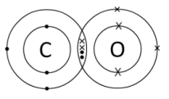
 |  |  |  | MgO
 |  |  | 