8He4 The rock cycle 2

Name _____________________________

Cut out the labels below and stick them on this diagram to show the rock cycle.

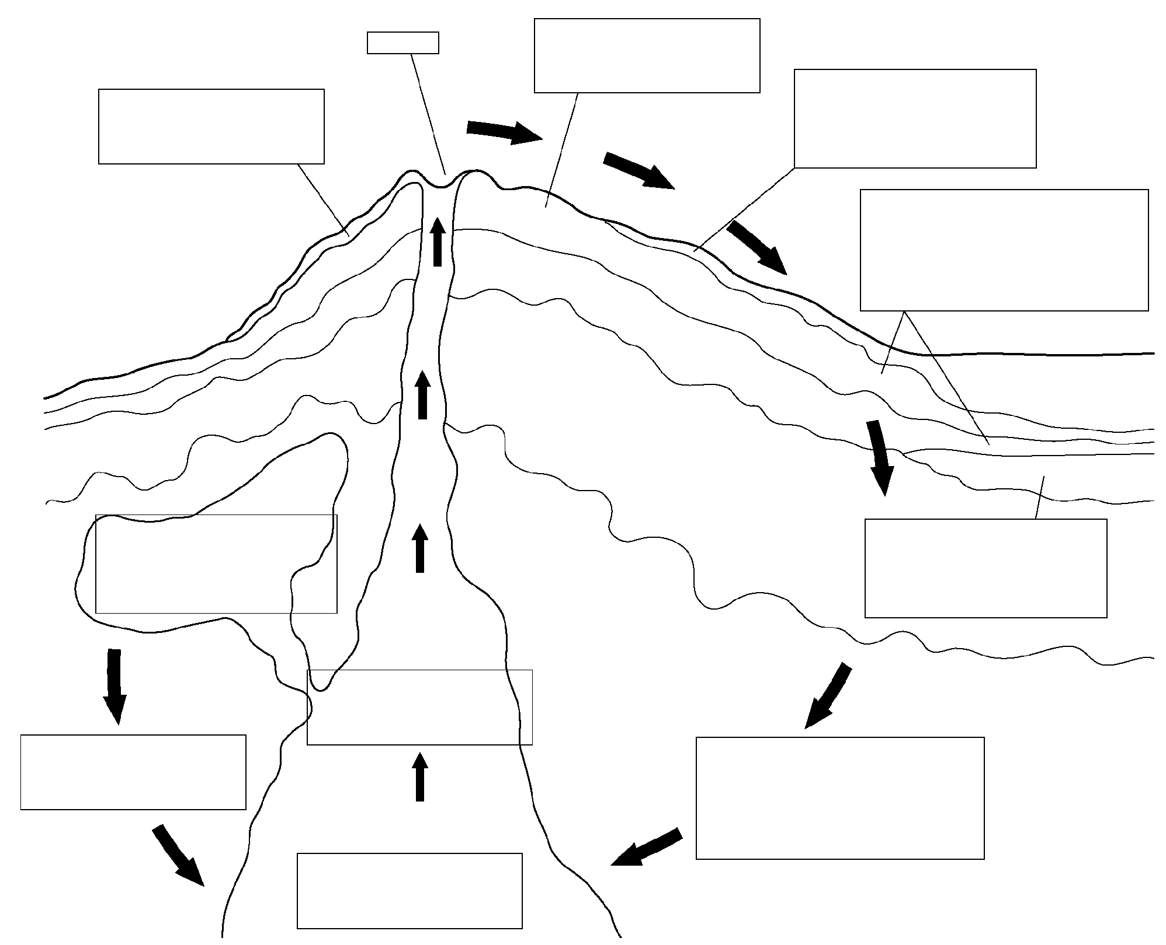

Cut out the labels below and stick them on this diagram to show the rock cycle.

Lava cools quickly on the surface to form igneous rocks with small crystals. | Magma rises to the surface of the earth. | Rocks get weathered by chemical and physical weathering. | Some igneous rocks are changed into metamorphic rock. | If the rock is heated enough, it melts and forms magma.

Some magma gets trapped, and cools underground to form igneous rocks with large crystals. | The layers of sediment gradually get squashed and eventually form sedimentary rock. | Small fragments of rock get transported away from rock faces by rain, streams and rivers.

Some sedimentary rocks get heated and squashed under the surface of the Earth. This changes the rock into metamorphic rock.. | When the river slows down, the bits of rock are deposited at the bottom of the river, or sea. Over many years, these bits of rock build up to form layers.

volcano

