8Gc3 Physical or chemical weathering?

Name _________________________ Class ____________

When chemical weathering happens, a rock reacts with a chemical such as acid in rainwater. A new substance is made.

When physical weathering happens, no new substances are made. The rocks do not change into a new substance, but they are

Biological weathering is when living things cause rocks to break apart or wear away.

For each diagram, decide what is causing the weathering, and if it is an example of chemical, biological or physical weathering. Fill in the gaps in the sentences using words from the box. You may need some words more than once.

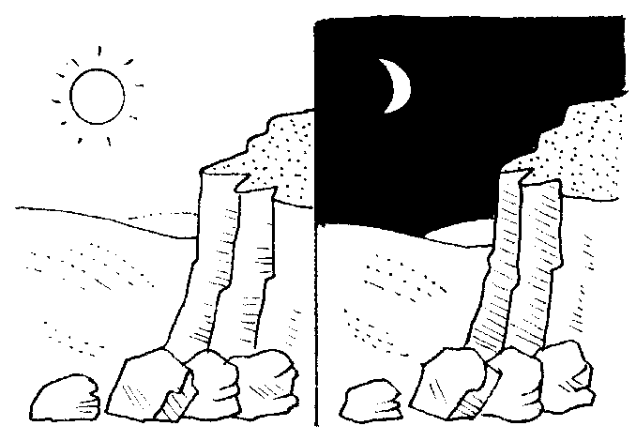 | 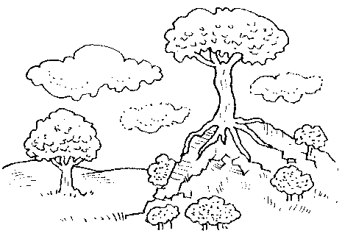
1 _______________ changes can cause  _______________ weathering. The rock  _______________ during the day when it  is hot and contracts when it is  _______________ at night. | 2 _______________ roots can cause  _______________ weathering. The plant  _______________ grow into small  _______________ in the rocks, and push  the sides of the cracks apart when they  _______________ bigger.
3 _______________ – _______________ action can  cause _______________ weathering.  Water in in the rock expands when it  _______________ and makes the crack bigger. |  | 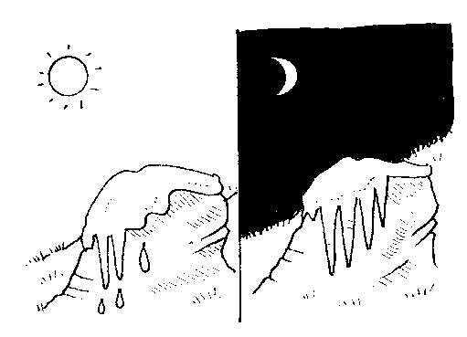

4 _______________ can cause _______________  weathering. The _______________ in the  rain dissolves parts of the rock. This process is  speeded up if the rain contains a lot of acid.  Rain like this is called _______________  _______________ and can be caused by burning  _______________ fuels. | 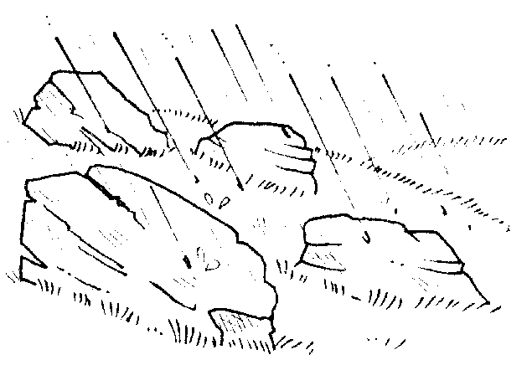

acid biological chemical cold cracks expands
fossil freezes freeze–thaw grow physical plant
rain roots temperature water

