8Ga5 Describing rocks 1

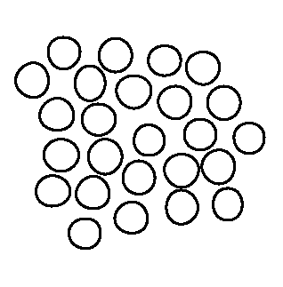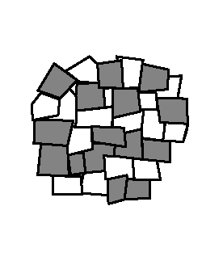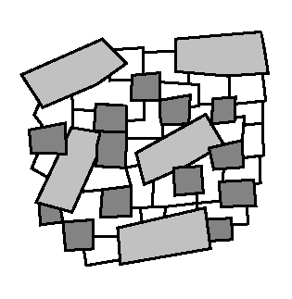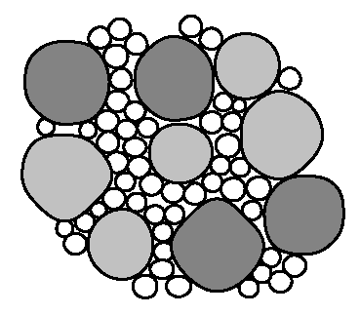
A B C D
not to scale

Rocks are mixtures of minerals. The grains in rocks can be different shapes and sizes. Interlocking grains (crystals) fit together without any gaps between them. If the grains are rounded, there can be gaps between the grains and the rock may be porous. Porous rocks can absorb water.

1 Which two rocks have interlocking crystals?
2 How many different kinds of mineral are there in:
a rock A
b rock B
c rock C
d rock D?
3 Which rock is made of rounded grains that are all the same size?
4 Which rock is made of several different sizes of rounded grains?
5 Which two rocks are porous?
6 Which rock do you think will absorb the most water? Explain your answer.
7 Read this description of granite.
‘Granite consists of three main minerals. One of the minerals often forms large crystals.’
Which rock could be granite?
8 Read this description of conglomerate.
‘Conglomerate is made of quite large, rounded pebbles, in a mixture of much smaller grains.’
Which rock could be conglomerate?

[ knowledge ]

