8Ce3 Immunisation

Name _____________________________ Class ____________

1 White blood cells in your body make antibodies. These attach to microbes and help to destroy them. Each different microbe has different shapes on its outside and the white blood cells need to make different antibodies to fit the different shapes. On the diagrams below, draw lines to show which antibodies will fit which microbes.

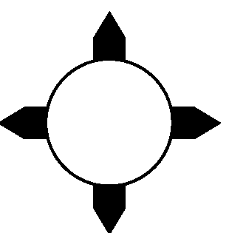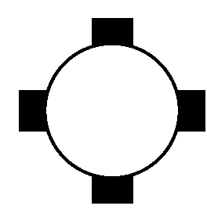

2 Use the words from the box to complete the sentences about immunisation.

antibodies blood disease injection microbes vaccine white

In an immunisation you are given an ________________ containing a ________________ .

This is some of the _________________ that normally cause a _________________ but

which have been treated so that they do not. It makes _________________

_________________ cells produce _________________ . These attack the vaccine and some

of them stay in the blood.

3 If a microbe cannot cause a disease in you, you are said to be immune.
Explain how a vaccine makes you immune.

_____________________________________________________________________

_____________________________________________________________________

_____________________________________________________________________

_____________________________________________________________________

