8Ca2 Which microbe?

1 The pictures show a virus, a bacterium and a yeast cell. Which one is which?

a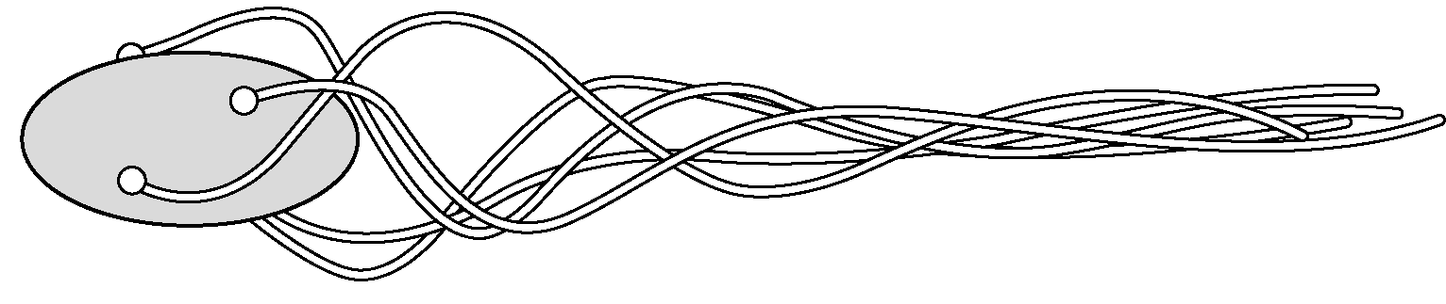
b c 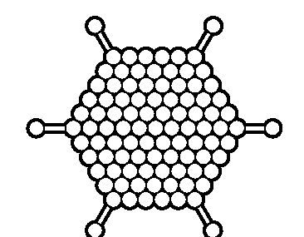Drawings not to scale

2 Look at the pictures in question 1 again.
a In real life, which one is the smallest?
b In real life, which one is the biggest?

Read the passage below and then answer the questions which follow.

Very small living things are called microbes or micro-organisms; ‘organisms’ because they are living things, ‘micro-‘ because they are very small. All living things should be able to carry out the seven life processes. However, viruses are a bit of an exception to this rule and some scientists do not think that they are really living. Of the seven life processes they can only reproduce and even then they cannot do this on their own – they need to be inside another living cell. However, most people think of viruses as micro-organisms because they are very small and, like all living things, contain genes.

3 a What is the proper name for a ‘living thing’?
b What is the other name for ‘micro-organisms’?
c What piece of equipment do you need to use to see micro-organisms?
d List the seven life processes.
e Which of these life processes can viruses not do at all?
f Which of these life processes can viruses do when inside another living cell?
g If they are not really living, why do people tend to call viruses ‘micro-organisms’?

